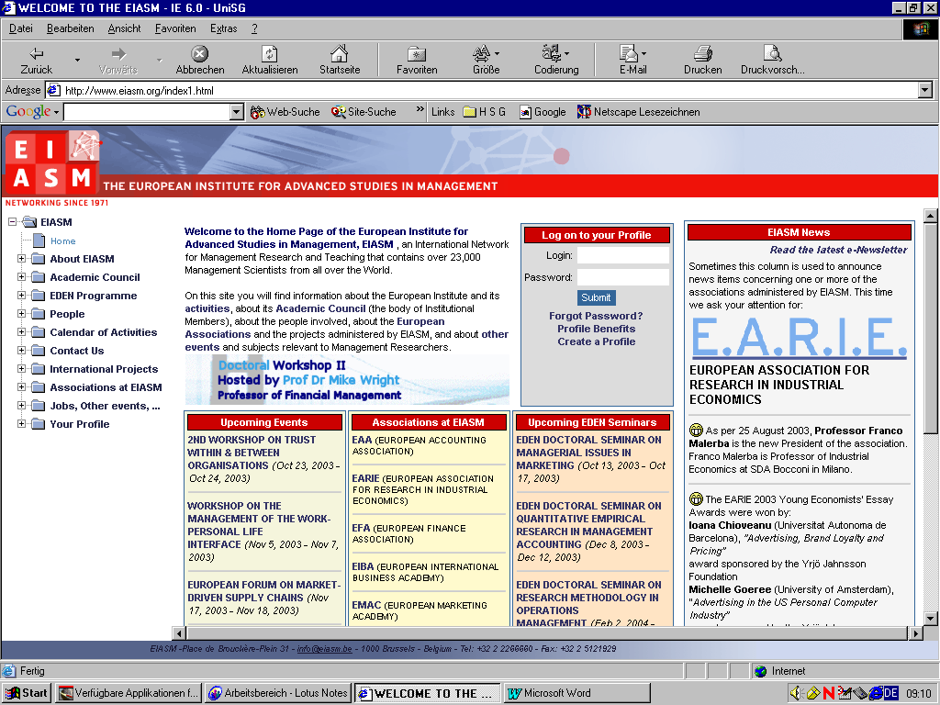 PLACE DE BROUCKÈRE-PLEIN - 31 - 1000 BRUSSELS - BELGIUM - Tel: 32 2 2266660 - Fax: 32 2 5121929

5th Workshop on Talent Management   
Copenhagen, Denmark  
  
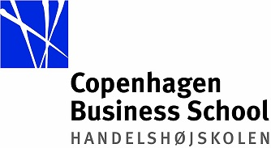

October 3-4, 2016   
  
PRELIMINARY PROGRAMME

**Monday October 3, 2016**

|  |  |  |
| --- | --- | --- |
| **Registration** | 08:00 – 8:30 |  |
| **Introduction** | 08:30 – 09:00 |  |
| **Keynote Speech:** Lucien Aalziari, SVP, Group HR and CHRO, A.P.Møller Maersk | 09:00 – 09:50 |  |
| **Parallel Sessions** |  |  |
| **TRACK A: Vlad Vaiman and Dana Minbaeva** |  | **TRACK B: David Collings and Sara Louise Muhr** |
| 1 EMPLOYEE REACTIONS TO TALENT MANAGEMENT: ASSUMPTIONS VERSUS EVIDENCE  DRIES, NICKY; GIVERNY De BOEK; MARIA CHRISTINA MEYERS | 10:00 – 10:30 | 6 UNDERSTANDING THE DYNAMICS IN TALENT MANAGEMENT: FROM A STATIC TO A DYNAMIC VIEW ON TALENT MANAGEMENT  THUNNISSEN, MARIAN; GALLARDO-GALLARDO, EVA |
| 2 TALENT POOLS: A SYSTEMATIC LITERATURE REVIEW AND RESEARCH AGENDA  JOOSS, STEFAN; RALF BURBACH; HUUB RUEL | 10:30 – 11:00 | 7 A SOCIAL IDENTITY PERSPECTIVE ON THE EFFECTS OF TALENT MANAGEMENT ON EMPLOYEES  APSLUND, KAJSA |
| **Coffee Break** | 11:00 - 11:20 | **Coffee Break** |
| 3 THE TALENT CLIMATE: CREATING SPACE FOR TALENT DEVELOPMENT THROUGH A STRONG TALENT SYSTEM  KING, KARIN A. | 11:20 – 11:50 | 8 THE RELEVANCE OF PARADOXES IN DIVERSITY AND TALENT MANAGEMENTTHE EXCLUSION-INCLUSION PARADOX  DAUBNER, DAGMAR |
| 4 DOES UNDERSTANDING THE VALUE OF TALENT MANAGEMENT HELP US UNDERSTAND WHAT TALENT MANAGEMENT REALLY IS?  MAKRAM, HEBA | 11:50 – 12:20 | 9 STORMING NORMS: TOWARDS A NORM CRITICAL APPROACH TO ORGANISATIONAL DIVERSITY AS INTERSECTIONALITY  CHRISTENSEN, JANNICK FRIIS |
| 5 LITERATURE REVIEW OUTLINE: BRIDGING TALENT MANAGEMENT VIEWED IN RATIONAL AND NATURAL SYSTEM PERSPECTIVE  OLMER, ILKKA | 12:20 – 12:50 | 10 THE IDENTIFICATION AND EVALUATION OF TALENT IN CROSS-BORDER ACQUISITIONS  HOLLAND, DENISE |
| **Lunch** | 12:50 – 14:00 | **Lunch** |
| 11 ARE ADULT THIRD CULTURE KIDS A SOURCE OF GLOBAL TALENT?  NYGAARD, KENNETH; JAKOB LAURING | 14:00 – 14:30 | 13 TALENT DEVELOPMENT: POST-SECONDARY’S PARTNERSHIP ROLE  FASSINA, NEIL |
| 12 MAPPING DYNAMICS IN TALENT MANAGEMENT RESEARCH  GALLARDO-GALLARDO, EVA; LILIANA ARROYO MOLINER; PEDRO GALLO | 14:30 – 15:00 | 14 DIFFERENT TYPES OF ORGANIZATIONS REQUIRE DIFFERENT TM PRACTICES –  AN EMPIRICAL INVESTIGATION OF STRATEGIC TM IN GERMANY  HARSCH, KATHARINA; FESTING, MARION |
| **Coffee/Tea Break** | 15:00 – 15:30 | **Coffee/Tea Break** |
| 15 STRATEGIC TALENT AND KNOWLEDGE MANAGEMENT - INSIGHT FROM MALAYSIA  ABU HASAN, NORHAFIZAH; ALEX MOHR; YANNIS GEORGELLIS | 15:30 – 16:00 | 18 MACRO-PERSPECTIVE IN GLOBAL TALENT MANAGEMENT: APPLICATION IN THE RUSSIAN CONTEXT WITH A VIEW TO LEARN  KUZNETSOVA, OLGA; VAIMAN, VLAD; HOLDEN, NIGEL |
| 16 TALENT MANAGEMENT PRACTICES IN THE RUSSIAN IT COMPANIES  KABALINA, VERONIKA; MONDRUS, OLGA | 16:00 – 16:30 | 19 MOVING TOWARDS INCLUSION IN CHINA:  A STUDY OF EMPLOYMENT BARRIERS OF TALENTS WITH DISABILITIES  KOEPPE, NATALIE; AKRAM AL ARISS; EDDY NG |
| 17 HOW DO JAPANESE MNCS IDENTIFY THEIR TALENT? : THE NEGLECTED ROLE OF RHQS IN GTM  KASAHARA, TAMIKO | 16:30 – 17:00 | 20 TALENT MANAGEMENT OF GOVERNMENT-SPONSORED STUDENTS IN KAZAKHSTAN: ITS IMPACT ON INDIVIDUAL CAREERS AND ON SOCIETY  MURATBEKOVA-TOURON, MARAL; DANA ABEUOVA |

**Tuesday October 4, 2016**

**Plenary Session**

|  |  |
| --- | --- |
| **Keynote Speech:** Prof.David Allen, Rutgers University | 08:30 – 09:20 |
| How Technology is changing the Talent Scene  Paul Evans, INSEAD | 09:20 – 09:50 |

|  |  |  |
| --- | --- | --- |
| **Track C: Hugh Scullion and Vlad Vaiman** |  | **Track D: David Collings and Dana Minbaeva** |
| 21 TALENT MANAGEMENT IN EMERGING MARKETS: THE ROLE OF PSYCHOLOGICAL CONTRACTS AND AMBIDEXTERITY CAPABILITY OF KEY PEOPLE IN CONFLICT ZONES  RAMIREZ, JACOBO; SERGIO MADERO; CLAUDIA PATRICIA VELEZ-ZAPATA | 10:00 – 10:30 | 22 ON THE TRAIL OF LINE MANAGERS AS TALENT SPOTTERS  BLANCO, MARIA; MARIELA GOLIK; RICARDO CZIKK |
| **Coffee Break** | 10:30 – 11: 00 | **Coffee Break** |
| 23 THE INFLUENCE OF MANAGER TALENT MINDSET AND CORE SELF-EVALUATION ON TALENT IDENTIFICATION OUTCOME QUALITY: A QUASI-EXPERIMENTAL FRAMEWORK  KING, KARIN A. | 11:00 – 11:30 | 26 WORK-LIFE MANAGEMENT: A QUESTION OF TALENT AND TALENT MANAGEMENT  LANGUILAIRE, JEAN-CHARLES |
| 24 TALENTED ENTREPRENEURS´ DECISIONS: RADICAL INNOVATION AND KNOWLEDGE SHARING  BLOMKVIST, MARITA; EANETH JOHANSSON; WAYMOND RODGERS | 11:30 – 12:00 | 27 ARE WOMEN PROMOTED FASTER? PROMOTION PRACTICES IN LARGE ORGANIZATIONS FOR MALE AND FEMALE TOP EXECUTIVES  HAMORI, MONIKA; ROCIO BONET; PETER CAPPELLI |
| 25 THE “CREAM OF THE CREAM”: TALENTS AS AN ELITIST ENDO-ORGANIZATION. EVIDENCE FROM A MULTINATIONAL COMPANY  BONNETON, DOMITILLE | 12:00 – 12:30 | 28 DOES TALENT MANAGEMENT WORK IN DISASTERS - MANAGING TALENT IN THE HUMANITARIAN AID CONTEXT  LUMME-TUOMALA, RIITTA MARIA |
| **Lunch** | 12:30 – 14:00 | **Lunch** |
| 29 NEW PARADIGM OF HRM: HUMAN CAPITAL AND THEORETICAL KNOWLEDGE  UYSAL, GÜRHAN | 14:00 – 14:30 | 32 GLOBAL TALENT MANAGEMENT FOR THE NEW DIPLOMAT  RUEL, HUUB; IRENE FELIUS; TANYA BONDAROUK |
| 30 ESTIMATING THE RELATIVE IMPORTANCE OF COMPETENCIES ASSOCIATED WITH TALENT POTENTIAL AND PERFORMANCE  UGGERSLEV, KRISTA LINDSAY; LAURA HAMBLEY; FRANK BOSCO; PIERS STEEL | 14:30 – 15:00 | 33 HUMAN CAPACITY: PUTTING THE HUMAN BACK INTO THE HUMAN RESOURCES - ORGANIZATIONAL PERFORMANCE (HR-OP) LINKAGE  SHABIYI, ADEOLA |
| 31 THE EVOLVING ROLE OF THE CHIEF SUSTAINABILITY OFFICER: RESPONSIBILITIES, ATTRIBUTES, & IMPACTS  REILLY, ANNE | 14:00 – 14:30 | 34 AN INVESTIGATION OF TECHNICAL ORIENTATED EXPATRIATES  NYGAARD, KENNETH; JAKOB LAURING |
| **Coffee/Tea Break** | 14:30 – 15:00 | **Coffee/Tea Break** |
| 35 SOCIAL IDENTITY COMPLEXITY AT WORK  LINDSAY, SARAH; JACK, GAVIN | 15:00 – 15:30 | 37 TALENT AND THE ABSENCE OF WORK IDENTITY - A CONCEPTUAL AND PHILOSOPHICAL CHALLENGE FOR TALENT MANAGEMENT  ADAMSEN, BILLY; MICHAEL AUGUSTINE |
| 36 INKING SUPPORTIVE TECHNOLOGY HR PRACTICES TO TALENT MANAGEMENT AND RAPID TECHNOLOGY ASSIMILATION AND EXAMINING SUBSEQUENT EFFECTS ON INNOVATION AND ORGANIZATIONAL COMPETITIVENESS  KONTOGHIORGHES, CONSTANTINE; PANAYIOTA KYRIACOU | 15:30 – 16:00 |  |
|  |  |  |
| **Plenary Session** | 16:00 – 16:30 |  |
| **Next year’s venue presentation** |  |  |
| **Conclusions and lessons learned** |  |  |